**Physics Innovation and Entrepreneurship (PIE) Introduced into the**

**First-year Physics Course**

Randall Jones, Ann Ernst, and Bahram Roughani

Departments of Physics & Engineering

Loyola University of Maryland

Baltimore, MD 21210

Hyperloop Problems – with Solutions

Constant Acceleration:

The [Hyperloop](https://www.youtube.com/watch?v=MU4LTv_eNgQ) is a futuristic transportation system (provide link) consisting of pods that would be able to travel at 760 miles per hour by magnetic levitation on tracks through a tube in which the air has been evacuated.

1. How long would it take to travel from Boston to Washington DC at that speed?  (The distance from Boston to Washington is approximately 630 km)
2. The pod must, of course, start from rest and accelerate up to its maximum speed and then decelerate to rest at the end of the trip. Assuming a “comfortable” acceleration of $1.5 \text{m/}{\text{s}}^{\text{2}}$ (approximately the acceleration of a jet plane on the runway), how much time would this add to the trip?
3. Assume the Hyperloop makes 4 evenly spaced stops in traveling between Boston and Washington, DC and waits at each station for 5 minutes to allow passengers to disembark and to board. How much time would be added to your answer to part b? Note that 4 stops means the distance is divided into 5 equal-length segments.
4. Does your answer to part (c) make the Hyperloop concept less attractive? What modifications might you consider to make this more feasible? This is an issue of “Human Desirability.”

SOLUTION:

1. The time can be determined from the equation for constant velocity: . First convert the given velocity to m/s:



Now find the time:



1. The time it takes for the train to accelerate to a velocity of 340 m/s and the distance it travels during this time can be determined using the constant acceleration equations:





The time and distance required for the train to stop are the same as the values to start. The distance that the train travels at constant speed is thus



and the amount of time required to travel this distance is



The total duration of the trip is thus



Thus note that we have added 3.8 minutes to the travel time and almost a quarter of the time is spent accelerating or decelerating.

1. The distance between stops is . The Hyperloop requires  for deceleration and acceleration at each stop, so it will be able to reach its maximum speed. The amount of time added to the trip with each stops would be the 3.8 minutes calculated in part b plus the 5 minute stop:



So adding these stops would more than double the time it takes to travel between Boston and Washington, D.C.

1. Can we get passengers on the train without it slowing down? See the following links:

<https://vimeo.com/25465925>

Centripetal Acceleration:

We have seen that the Hyperloop will have a maximum speed of 760 mi/hr which is approximately 340 m/s. We have also determined that the Hyperloop can travel at a constant speed if there are detachable cars that can be added and removed at each station. If the Hyperloop is to start in Boston and pass through Providence, RI; New Haven, CT; New York City, NY; Philadelphia, PA; and Baltimore, MD before reaching Washington, DC it clearly cannot do so by traveling in a straight line; it’s path will be a series of arcs that allow it to pass through each station. When the Hyperloop goes around a bend, there will be a centripetal acceleration. We need to ensure that this acceleration is not too large.



Using the map at the right, estimate the “tightest” turn the Hyperloop will need to make to pass through each of these stations. Use the compass (circle drawing compass) at your table to try to construct a series of arcs that gets to each station (there cannot be any “corners” in your path). Then use the scale at the bottom of the map (50 miles = 2.3 cm) to determine (approximately) the radii of these arcs. Finally, determine the centripetal acceleration that passengers will experience on the tightest turn. What do your numbers suggest about the feasibility of the Hyperloop design?

SOLUTION:

One way to draw the arcs is shown below. The arc between New Haven and New York seems to have the shortest radius of curvature. The radius length is approximately 3.5 cm, so the radius is equal to



The centripetal acceleration is thus

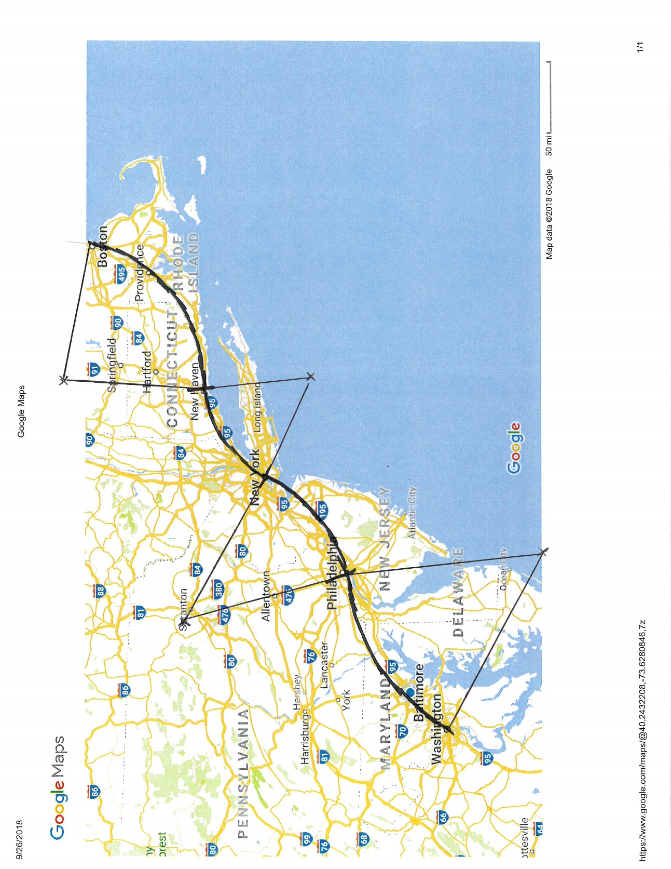 

So this seems within our acceptable value of acceleration.

Combination of Tangential and Centripetal Accelerations:

In previous Hyperloop activities we have seen that passengers on the Hyperloop will experience a centripetal acceleration because the path of the train must involve curves if it is to go through the major cities on the East coast. The arc of the track that starts from Boston, heading through Providence to New Haven has a radius of curvature equal to about 100 miles or 161 km. When the train is leaving Boston it is experiencing linear acceleration (increasing speed) and also moving around the curve and experiencing centripetal acceleration. These two accelerations are perpendicular to each other (the linear acceleration is often called the “tangential” acceleration when the path is around a curve, so we will call it ), and the total acceleration is the vector sum of these two:



Initially, the speed of the train is zero, so the centripetal acceleration is zero, but as the train picks up speed the centripetal acceleration increases (as ).

1. Determine the total acceleration just as the train reaches its maximum speed of 340 m/s if the tangential acceleration is .
2. We had determined that  was the maximum comfortable acceleration that passengers should experience. If we want the maximum total acceleration to be , what value of the tangential acceleration is acceptable? How much further will the train travel before reaching its maximum speed with this acceleration (as compared to the original linear acceleration of )?

SOLUTION:

1. At its maximum speed the centripetal acceleration is



At this point the tangential acceleration will drop to zero since the train has reached its maximum speed, but just before this happens, the combined acceleration is



1. The maximum centripetal acceleration along this curve will be  so if we want to keep the total acceleration below  we must have



The distance traveled before reaching the maximum speed is determined from



With an acceleration of and a final velocity of 340 m/s we find



With an acceleration of and a final velocity of 340 m/s we find



So the difference is about 5 km.

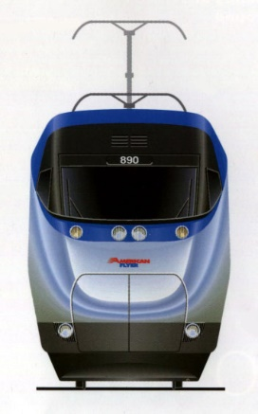Work & Energy and Friction:

The mass of the Hyperloop train is expected to be about the same as the mass of the Amtrak Acela trains, which is approximately 350 metric tons for an eight car train. Ignoring friction, how much work must be done on the Hyperloop to bring it from rest to its cruising speed of 340 m/s?

The required work is equal to the change in kinetic energy:



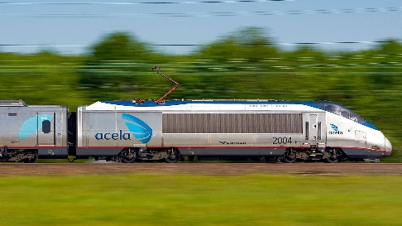The most important friction effect is air resistance. A frontal cross-section of a train such as the Hyperloop (or the Amtrak Acela shown at the right) has an area of about . The air resistance force acting on it is given by



where  is the density of air, *A* is the cross-sectional area of the train and *v* is the speed of the train. The constant *C* is called the drag coefficient. It is equal to 1 for a flat surface and is less than 1 for a tapered “aerodynamically designed” surface. It is approximately 0.6 for the Acela design shown at the right. Assuming the same drag coefficient for the Hyperloop, calculate the air resistance force that is exerted on the Hyperloop train when it travels at top speed.



How much work would the air resistance force do on the Hyperloop train if it travels from Boston to Washington, DC (distance = 630 km) at its maximum speed?



This work would cause a decrease in the kinetic energy of the train, causing it to slow down, but the motors do positive work on the train to keep its speed constant. What is the rate at which the motors must do work in order to keep the train running at a constant speed?

We had calculated the time required for the Hyperloop to make this trip as 1850 seconds, so the rate is



Another way to calculate power is



In order to reduce the amount of power needed, the Hyperloop would operate in a sealed tube, where the pressure has been reduced to 1/1000th that of atmospheric pressure. This means that the density of the air would be reduced by a factor of 1000. Calculate the air resistance force in this case and the power needed to maintain the top speed.

The air resistance force is simply reduced by a factor of 1000 if the density is reduced by 1000, so the force is



And the power required is also reduced by a factor of 1000:



The Amtrak Acela train requires approximately 3600 KW to operate at its top speed of 70 m/s. What do you think about the practicality of the Hyperloop based on these energy considerations? What about that initial calculation of the work required to get the train to its maximum speed? Is that a concern?

Momentum:

A potential disaster involving the Hyperloop would be a head-on collision between two Hyperloop trains. This would undoubtedly result in huge accelerations of the trains and passengers that would surely kill everyone on board. One possible method of reducing the accelerations would be to mount a large spring on the front of each train that would compress if the trains collided, taking some of the energy out of the system (transferring it to spring potential energy)

1. Suppose two identical passenger capsules, each with a mass of about 4000 kg are moving towards each other with speeds of 340 m/s. When they collide, their springs compress, transferring all of the kinetic energy of the capsules into spring potential energy. If the springs are designed to compress a total distance of 10 m (30 feet) in this scenario, what must the value of the spring constant be?

SOLUTION:

The combined kinetic energy of the two capsules is



If this energy is transferred to potential energy of two springs, that are each compressed 10 m, we find



This is certainly a very big spring!

1. What will be the maximum acceleration of the train in the scenario described above? Note that the acceleration is not constant since the spring force is not constant, but also note that the spring is the only force that acts on the train (gravity and normal force cancel) that causes the acceleration.

SOLUTION:

The maximum acceleration occurs when the spring is at its maximum compression, which occurs just when the trains stop momentarily. The net force on each train is



The maximum acceleration is thus



This is more than 1000 times the acceleration due to gravity, which doesn’t seem very survivable!

1. Consider the case where one Hyperloop capsule might run into a second capsule that is initially at rest at a station. Assume that the trains have springs as described above that are attached on the front and back. Determine the maximum compression of each spring in this case and the maximum acceleration of the capsules. Note that maximum compression occurs at the instant that the two trains are traveling with the same velocity. This is similar to the situation in which two objects collide and stick together, but the kinetic energy that is lost in the stick-together collision is transferred to thermal energy. The kinetic energy that is lost in this scenario goes into potential energy of the spring at maximum compression.

SOLUTION:

Since there are no external forces on the two springs we can use conservation of momentum to determine the velocity of the two trains at the point of maximum compression of the springs (since the two capsules are moving at the same speed). Since the masses are the same, this is fairly simple:



The decrease in kinetic energy can be calculated easily as well:

 

So the decrease in kinetic energy is



This energy goes into potential energy of the two springs, so we find



The spring force is equal to the net force on each capsule, so the acceleration is



This is still more than 800 times more than the acceleration due to gravity, so it looks like our passengers are in trouble.

1. What other ideas can you come up with to reduce the acceleration that passengers would experience in a collision? Or, what ideas can you come up with to avoid collisions?

Special Relativity:

The Hyperloop has a maximum speed of 760 miles/hour. If the Hyperloop were to travel at that constant speed in traveling from Boston to Washington, DC (approximately 630 km), how much younger would the train passengers be than those people who remained at rest relative to the Earth?

It will be helpful to know that for small values of , the Lorentz factor may be written

 for small 

SOLUTION:

First convert the speed to m/s:



The trip time as measured in the Earth frame is given by



The proper time is that measured by passengers on the Hyperloop, and is given by



This will be shorter than the time measured on the Earth, so we are interested in calculating



The value of  is  with 

In this case, we have



If you try to evaluate  on your calculator with this value of  you will probably just get . Using the expression given above for  when  is small you can determine the difference in ages:



Note that the  in the denominator can be ignored since it is added to 1. In the numerator, however, the 1’s cancel, so the  is important. Putting in numbers gives



The most accurate clock in existence today loses one second every 15 billion years:

<https://www.theverge.com/2015/4/22/8466681/most-accurate-atomic-clock-optical-lattice-strontium>

so it could certainly measure this time difference, but it doesn’t seem like “stay young by riding the Hyperloop” will be a successful marketing strategy!

Gravitation:

The International Space Station orbits the Earth a distance of 254 miles above the surface of the Earth. Draw a rough sketch of the Earth and the space station orbit. Determine the speed of the space station in miles per hour. Compare this to the speed of the Hyperloop (just kidding!).

SOLUTION:

The radius of the Earth is  (look it up!) and the height of the space station above the Earth is



so the distance of the space station from the center of the Earth is



So the Space Station is not really very far from the surface of the Earth (but the atmosphere extends to only about 60 miles above the Earth (a very thin, protective shield), so the Space Station is far above the top of the atmosphere).

The speed is determined by recognizing that the gravitational force provides the net force to produce the centripetal acceleration:



Solving for *v* gives



Converting this to miles per hour gives





Human-Generated Mechanical Power: Non-Hyperloop Problem

Work, Energy and Power:

Approximately, what is your change in gravitational potential energy when you climb a set of stairs?



Make an estimate of your mass and the height of a flight of stairs (look it up!).

Note: let students choose their own numbers for these problems (within reasonable limits!).

 



Approximately, how much work do you do when you climb a set of stairs?



Note that you do this work on yourself – seems a bit odd, but it is like a car doing work on itself when it speeds up

Approximately, what is your power output when you (leisurely) climb a set of stairs? I’m thinking of what rate of stair climbing you might maintain for say half an hour.



How long does it take to *leisurely* climb a set of stairs? Go do it!





This is actually pretty high. Don’t let students come up with a number any bigger than this – make them go climb from the basement to the third floor!

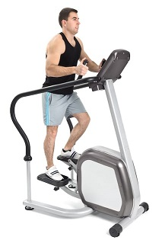Suppose you “climb” the same distance on a stair-climbing machine. Is the work you do the same? If so, where does the energy go?

Seems like the work you do must be the same, but it no longer goes to increasing your gravitational potential energy. Instead, the energy is “lost” to thermal energy (the room warms up).

Can you think of ways you might use the information you have just learned?

I’m hoping students will come up with ideas like charging their cell phones using the energy they generate on a stair-climber. Or power a stereo, or light a light. Can the energy expended at the FAC be used in some fashion (besides heating the building!)?

Possible Applications of Human-generated Mechanical Power:

Consider Sub-Saharan Africa

* 80% of Sub-Saharan Africans are farmers – Irrigation is a major challenge in this part of the world.
* Electricity, gasoline, oil are not widely available and expensive when they are available

The $1000 question:

* Could we develop a human-powered pump for irrigation in Sub-Saharan Africa?
* Would you invest $1000 in my company?

Initially, this is a feasibility question…

What do we need to know/assume/estimate to answer this question?

* How much land do we want to irrigate ?
* How much water do you need per acre?
* How high do we need to lift the water?
* How long can a person operate a pump?

How do we determine the answers to these questions?

Make assumptions and/or use Google!

Do it!

How much land?

1 acre seems reasonable

How much water? – Google it!

One answer I’ve found is 10,000 liters per day per acre. There is a broad range of possible answers, let students work with whatever they can find.

How high must we lift the water?

10 m seems reasonable (lifting from a well perhaps)

How long can a person operate a pump

2 hours seems reasonable (several people could take turns)

Feasibility of a human-powered irrigation pump:

How long does it take to pump enough water to irrigate one acre?

One liter of water has a mass of 1 kg so the work required to raise 20,000 liters 10 m is



If we do 150 J of work every second, the time required is



Note: Student answers may vary depending on number chosen above.

So… it looks feasible

Would you invest $1000?

Go to <http://kickstart.org/> and watch the video

The All-Terrain Wheelchair

How much torque must be applied to the large wheel of a wheelchair to keep it stationary on the ramp?